BLS INTERNATIONAL SCHOOL



PROJECT REPORT

ON

# SHOPPING MANAGEMENT SYSTEM

**Submitted By: Submitted To:**

Vansh Agarwal Mr Vivek Upadhyaya

XII A (PGT Comp. Sci. Dept.)

## BONAFIDE CERTIFICATE

This is to certify that this project report on the topic “SHOPPING MANAGEMENT SYSTEM” is the Bonafide work of **Vansh Agarwal,** Student of **Class-XII(PCM)**. This report is submitted as a part of the Practical Board Examination in Computer Science for the session 2024-25.

_____________________

Signature

Mr Vivek Upadhyaya

(PGT CS Deptt.)

## ACKNOWLEDGEMENT

On the auspicious occasion of submitting my Computer Project, I am deeply obliged and thankful to my Computer Science Teacher **Mr. Vivek Upadhyaya** without the righteous and guided assistance of whom, this project would not have

seen the daylight. He devoted his precious time in bringing my work to this stature. I also pay thanks to my parents, our

Principal Mam **Mrs. Karnika Srivastav** for giving me full support throughout the completion of my project.

Vansh Agarwal

Class: XII A (PCM)

INDEX

|  |  |  |
| --- | --- | --- |
| S.No. | Contents | Page |
| 1. | Overview of Python | 5 |
| 2. | Abstract: Need for Project | 8 |
| 3. | User Manual | 11 |
| 4. | Database Structure | 15 |
| 5. | Source Code | 18 |
| 6. | Screen Shots | 49 |
| 7. | Bibliography | 51 |
|  |  |  |

## OVERVIEW OF PYTHON

Python is a high-level, interpreted, interactive and object-oriented scripting language. Python is designed to be highly readable. It uses English keywords frequently where as other languages use punctuation, and it has fewer syntactical constructions than other languages.

* **Python is Interpreted** −Python is processed at runtime by the interpreter. You do not need to compile your program before executing it. This is similar to PERL and PH P.
* **Python is Interactive** − You can actually sit at a Python prompt and interact with the interpreter directly to write your programs.
* **Python is Object-Oriented** − Python supports Object-Oriented style or technique of programming that encapsulates code within objects.
* **Python is a Beginner's Language** − Python is a great language for the beginner-level programmers and supports the development of a wide range of applications from simple text processing to WWW browsers to games.

**Python Features**

Python's features include –

* **Easy-to-learn** − Python has few keywords, simple structure, and a clearly defined syntax. This allows the student to pick up the language quickly.
* **Easy-to-read** − Python code is more clearly defined and visible to the eyes.
* **Easy-to-maintain** − Python's source code is fairly easy-to maintain.
* **A broad standard library** − Python's bulk of the library is very portable and cross-platform compatible on UNIX, Windows, and Macintosh.
* **Interactive Mode** − Python has support for an interactive mode which allows interactive testing and debugging of snippets of code.
* **Portable** − Python can run on a wide variety of hardware platforms and has the same interface on all platforms.
* **Extendable** −You can add low-level modules to the Python interpreter. These modules enable programmers to add to or customize their tools to be more efficient.
* **Databases** − Python provides interfaces to all major commercial databases.
* **GUI Programming** − Python supports GUI applications that can be created and ported to many system calls, libraries and windows systems, such as Windows MFC, Macintosh, and the X Window system of Unix.
* **Scalable** − Python provides a better structure and support for large programs than shell scripting.

Apart from the above-mentioned features, Python has a big list of good features, few are listed below –

* It supports functional and structured programming methods as well as OOP.
* It can be used as a scripting language or can be compiled to bytecode for building large applications.
* It provides very high-level dynamic data types and supports dynamic type checking.

## ABSTRACT

This Shopping Management System is designed to support small scale vendors by simplifying store management through digital tools. Small businesses often struggle with limited resources and manual processes, which can lead to errors and limit growth. This system addresses these issues by providing features like order tracking, customer management, stock updates, and automated billing, which help reduce paperwork and improve accuracy in cash management.

The intuitive interface makes it easy for vendors to track sales, monitor stock, and maintain customer records without technical expertise. Automated record-keeping allows vendors to manage data quickly and error-free, helping them make informed decisions based on sales trends and customer activity.

In essence, this project empowers small vendors to scale their operations efficiently, enhancing productivity and accuracy while reducing manual workload. It enables them to focus on serving customers better and growing their business in today’s digital age.

The **Shopping Management System** provides an efficient, digital platform for managing a small-scale store, aimed at assisting vendors in tracking inventory, managing orders, and maintaining customer records. Key functionalities include:

1. **Product Management:** Add, update, or remove products from the system, ensuring inventory is always current.
2. **Order Processing:** Create and manage customer orders with automated record-keeping, which simplifies sales tracking and reduces manual errors.
3. **Customer Database Management:** Maintain essential customer details such as names, mobile numbers, and order histories to improve service and loyalty tracking.
4. **Cart Management**: Customers can add, view, and modify items in their cart, allowing flexibility before finalizing a purchase.
5. **Billing and Checkout:** Generate detailed bills, including tax calculations and any applied discounts, creating clear, error-free transactions.
6. **Daily Sales and Earnings Report:** Provides a daily summary of total sales and earnings, helping vendors assess business performance.
7. **Order Search and Tracking:** Customers can search their previous orders by mobile number, and admins can view order details, especially for today’s orders.
8. **Admin Authentication:** Secure login for the admin interface to protect sensitive business information.
9. **User-Friendly Interface:** A professional, organized layout that ensures all functions are easy to access and navigate.
10. **Order History and Record Keeping**: Stores all transactions with customer and order details for future reference, reducing the need for manual paperwork.

## USER MANUAL

**Admin Functions:**

1. **Add Product**: This function allows the admin to add new items to the store’s inventory. When selected, the system prompts for key details like the product name, category, price, and stock quantity. After input validation, the product is saved into the database. A confirmation message displays once the product is successfully added, keeping inventory updated and accessible.

2.**Update Product**: This feature enables the admin to modify existing product details, such as price or stock quantity. By selecting this option, the admin provides the product ID and the updated information, which the system then validates and updates in the database. A success message confirms the update, ensuring accurate and current inventory records.

3.**Delete Product**: The admin can remove outdated or unavailable products from the inventory using this function. Upon entering the product ID, the system verifies its existence and deletes the product from the database. This keeps the inventory list clean and relevant, with a confirmation message displayed once the deletion is complete.

1. **View Products**: This function allows the admin to view all available products in a neatly formatted table. It retrieves product details such as ID, name, category, price, and stock from the database and displays them in a well-organized layout on the screen. This feature enables the admin to get a quick overview of inventory status at any time.
2. **View Orders**: This function enables the admin to see all orders placed on the current day, providing a clear summary of sales activity. The order details, including customer names, mobile numbers, items, and prices, are displayed in a table format, making it easy to review. At the end of the list, the system calculates and displays the total earnings for the day, assisting with daily financial tracking.
3. **Search Orders by Customer**: This feature allows the admin to search for specific orders based on a customer’s mobile number. The system retrieves all matching orders from the database and displays them in a table format, helping the admin locate order histories quickly for customer service or record-keeping.
4. **Admin Login**: To secure sensitive functions, the admin must log in using a designated username and password. Upon entering valid credentials, the admin gains access to the full range of system management options. This feature ensures that only authorized users can modify inventory or view detailed sales data.

**Customer Functions:**

1. **Add to Cart**: Customers can select items to add to their cart by entering the product ID and quantity. The system checks availability and adds the item to the cart if the stock is sufficient. After each addition, the customer is prompted to add more items if needed. This feature makes shopping convenient and customizable.
2. **View Cart:** This function displays the current items in the cart, showing details such as product name, quantity, and price per item. The total price for all items in the cart is calculated and displayed at the bottom, providing the customer with a clear overview before proceeding to checkout.
3. **Update Cart:** This feature allows customers to make adjustments to their cart items, such as changing the quantity or removing an item entirely. By keeping the cart flexible, the system ensures that customers can finalize their selection before checkout, improving overall satisfaction and accuracy in orders.
4. **Checkout:** During checkout, the system generates a detailed bill that includes the itemized list of products, total price, and additional charges like GST and discounts (if applicable). The customer is prompted to enter their name and mobile number, which are saved with the order for future reference. This organized billing process adds professionalism and clarity to the transaction.
5. **Order History**: Customers can view past orders by entering their mobile number. The system retrieves and displays previous transactions in a list format, making it easy for customers to reference previous purchases or reorder items if needed. This feature enhances convenience and fosters loyalty by keeping a

reliable record of customer interactions.

### Database Structure

**ALL THE TABLES USED:**

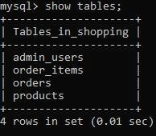

**1. Admin Table**: This table stores admin credentials for secure login. It includes:

○ **admin_id** (INT, Primary Key): A unique identifier for the admin.

○ **username** (VARCHAR): Admin username for login.

○ **password** (VARCHAR): Password for secure access.

The admin table restricts access to sensitive functions and ensures only authorized users can modify inventory and sales data.

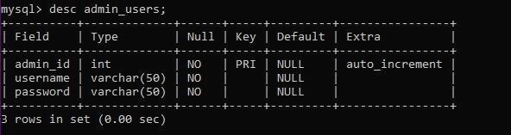

1. **Products Table**: This table stores all product-related information in the inventory. Each row represents a unique product, with columns including:
   1. **product_id** (INT, Primary Key): A unique identifier for each product.

○ **name** (VARCHAR): The name of the product.

○ **category** (VARCHAR): The category to which the product belongs.

○ **price** (FLOAT): The selling price of the product.

○ **stock** (INT): The quantity of each product available in inventory.

This table helps maintain an organized inventory by recording essential product details, enabling easy access and updates.

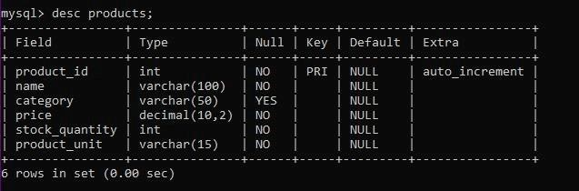

1. **Cart Table**: The cart table temporarily stores products that a customer has added to their cart. It includes:
   1. **cart_id** (INT, Primary Key): A unique identifier for each cart entry.

○ **product_id** (INT, Foreign Key): Links to the product in the Products table.

○ **quantity** (INT): The quantity of each product in the cart.

The cart table allows customers to select multiple items and make adjustments before finalizing their purchase.

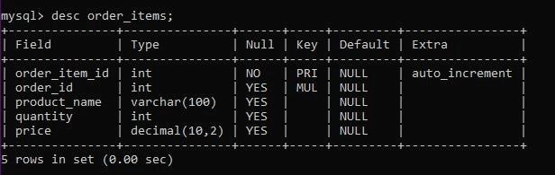

1. **Orders Table**: This table records finalized customer orders, helping track past transactions. Columns include:
   1. **order_id** (INT, Primary Key): Unique identifier for each order.

○ **customer_name** (VARCHAR): The name of the customer

○ **mobile_number** (VARCHAR): Contact number for customer identification.

○ **total_price** (FLOAT): Total amount due, including taxes and discounts. ○ **order_date** (DATE): The date of the order.

By keeping a record of each completed transaction, this table aids in order tracking, generating daily sales reports, and viewing order history.

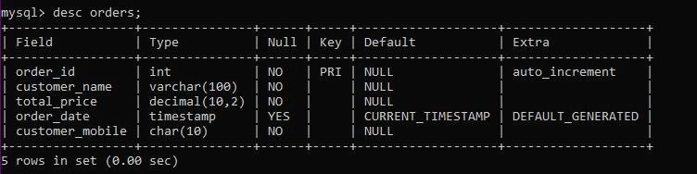

### Modules Used

The following Module are used for different functions used in my project:

**Modules Respective Functions/objects**

|  |  |
| --- | --- |
| **OS** | os.system(‘cls’) |
| **mysql.connector** | Mysql.connector.connect() , cursor.execute() , cursor.commit() , cursor.fetchone() ,  cursor.fetchall() |
| **Date Time** | date.today() |
| **Time** | time.strftime('%Y-%m-%d %H:%M:%S') |